FROM: OKELLO AMBROSE BOB – LIRA CHURCH OF CHRIST – UGANDA
  - To: The Elders And Brethren At Walter Hill Church of Christ – USA
Ref: April 2026 Evangelism

THROUGH: TRAMPAS MCCRACKEN

Dear brothers and sisters in Christ!
Greetings and hoping that the Lord has kept and blessed all you're doing for the growth of His Kingdom. Praying for those unwell among you. Back home we are okay and doing good except that my family has been and is still sick. Pray for our two boys Darren and Donnie who are undergoing treatment.
I am much extremely glad to find this opportunity of speaking to you though this report concerning the Lord's work I and the rest of the brothers with me are trying with our label best to do. We are indeed trying to do our best through every available opportunities see that the truth spreads, with God taking the glory.
For the month of April, I am glad to share that the usual work we had been doing in the past did hold including hosting Don and Tracey with also fellow brethren from within the country mostly those residing in the North and Eastern parts of the country. Been a blessing hosting the two who dedicated their precious times to teach the men's and women's classes and on other arrangements Don would teach great general lessons to the brethren.
I would love to in this report highlight on the following,
- Gospel Meeting Held In Lira.
Don and Tracey Hooton who have been to Uganda on several occasions to partner in building souls for Christ did come again at the beginning of April for the very purpose.
We made arrangements and settled to camping in Lira to teach and preach to a section of audience I had intended for them to meet. Souls I believed if built up would in turn impart the attained knowledge on others to live fruitful, faithful lives.
At the conclusion of the meeting, a total of seventy ( 70) men and women without children were able to have received their instructions. A soul ( Vivian ) from Lira was also baptized into Christ with one Joshua Okello admitting to recieve his the following morning but did not afterwards give us the time of performing it. I connected him to the brethren closer to his work station and we are hoping to hearing any further news from the referral.
Thankfully, God allowed a successful meeting with Don and Tracey departing to meet a group over in Kampala before leaving for Burundi. It was a blessing hosting the two and others.
- Saturday Radio Evangelism Program
I am always with the team of Joshua Ekwang, Billy Ojok who are converts of the arrangement back during the Covid days and sometimes with Ellias Omara and Benjamin Olao who equally got converted at the time I was actively doing the work of evangelism in Kole district where Church of Christ- Acankado is.
These men have earnestly stood along and contested earnestly for preserving and proclaiming the truth of Jesus Christ. Their commitment and dedication to the Lord’s work has helped much in providing leadership in the local Churches we have established in the past. It was difficult to keep up with all the local congregations we have established because of unwillingness and dedication of the men in those particular areas.
The radio work is offering opportunities of preaching to the lost and also edifying souls from congregations in the neighbourhood. We are in constant engagement with some of the men and women who positively call in to appreciate hearing the truth and desiring to hear and learn more from God's word. We hope this program is able to continue for a longer time and further many opportunities to the rest of the population in the North and some Eastern Uganda districts.
- Wednesday Bible Classes
For now we are teaching through the series " How To Study The Bible " from the books mailed to me by Rob Harbison. It's an excellent book which with a bit of my own knowledge of the subject, I am able to drive in and speak to my brothers and sisters during class sessions. I can testify that the brethren are beginning to make meaning of the subject.
A few of our friends and prospects are usually in attendance from who we expect an understanding of the subject and God willing respond to the invitations in them and see them finally become Christians.
- Social Media Handles
Especially Facebook, WhatsApp and Tiktok are currently trending with a lot of news for their users. A lot is there including soul conflicting ones. Like before, I am regularly posting sermons we do preach mostly in my dialect to interact with my people who are thankfully reaching out. Trying to employ many other approaches of sending out the saving message of truth to the lost and dying world. We pray and hope that it's all for the glory of God's name.
- Transportation.
I am so sorry to be over reaching out concerning this, I have an old car which l use for group distant trips for evangelism, carrying some less priviledged brethren including my family on Sundays and other days in case we have arrangements to meet together.
I am doing repairs that do swallow a lot of my support while having many other matters to handle with it. Lately, I was returning from a funeral when it broke down. If it must drive me for a longer period, I will need to replace it's engine with also it's gear box which is costly. The other option is to sell and top up an amount and buy another one to keep me safe and moving longer on roads in doing the Lord's work.
I do pray and hope that at a point in time, God will open doors to see this through. The motorcycle I had is being used by my brother Billy for his work with the Omoro Church Of Christ, a congregation we established through the radio ministry.I have changed two of its Tyres from the support I have been receiving from the past month and this. Buying all would leave me empty and not having enough to do my work of preaching and teaching the gospel of Christ.

PICTURES
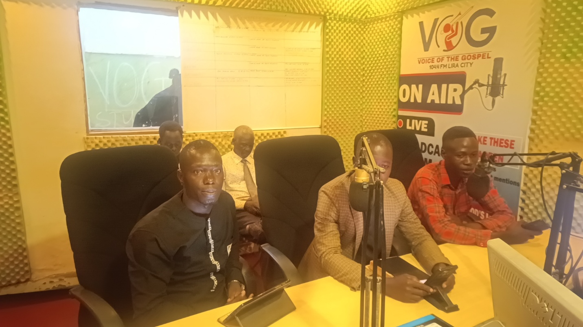
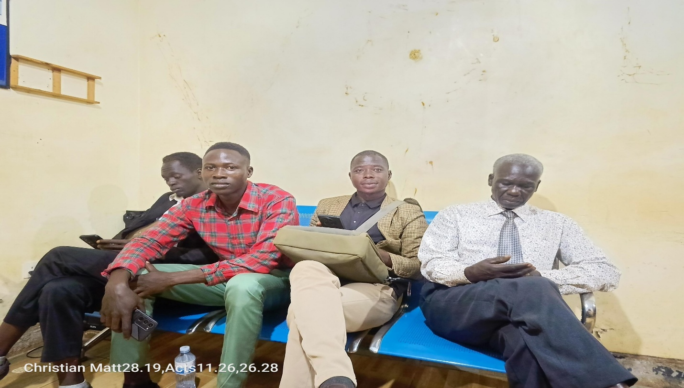
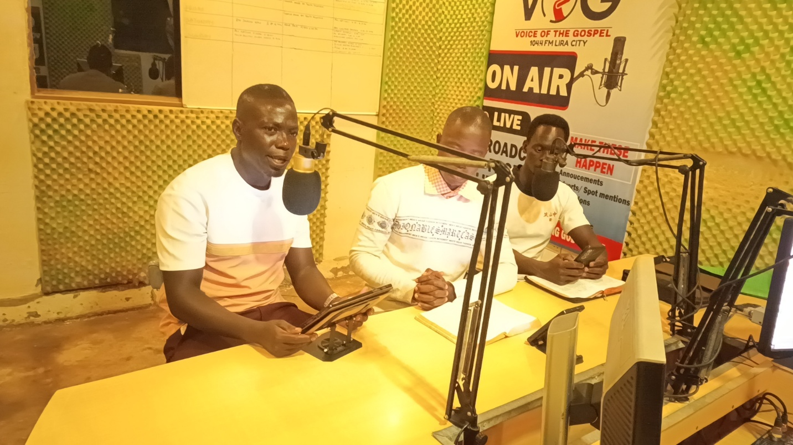
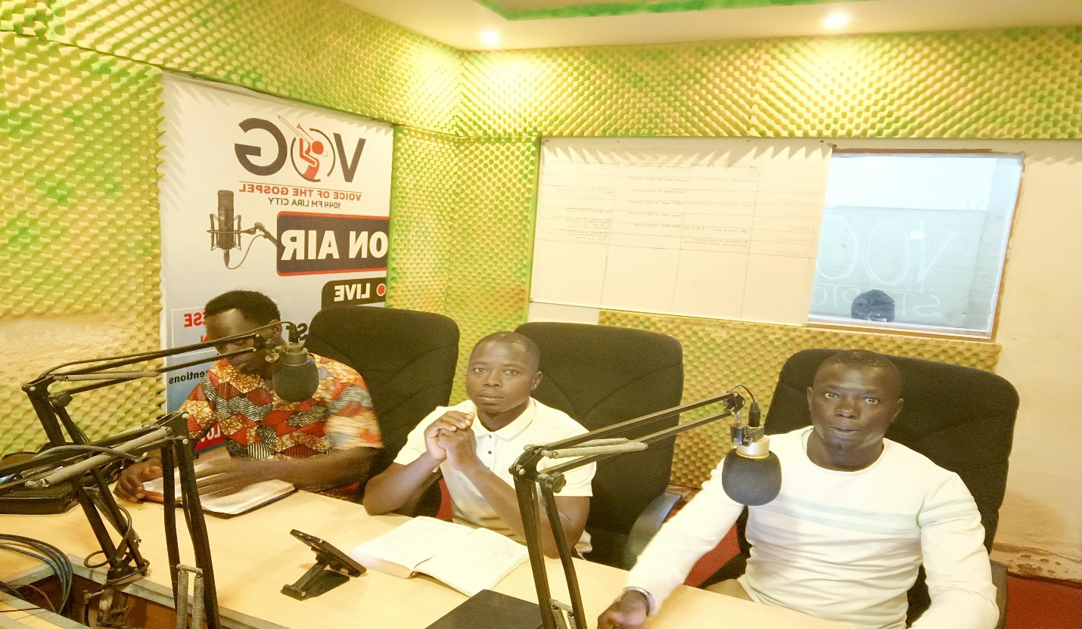

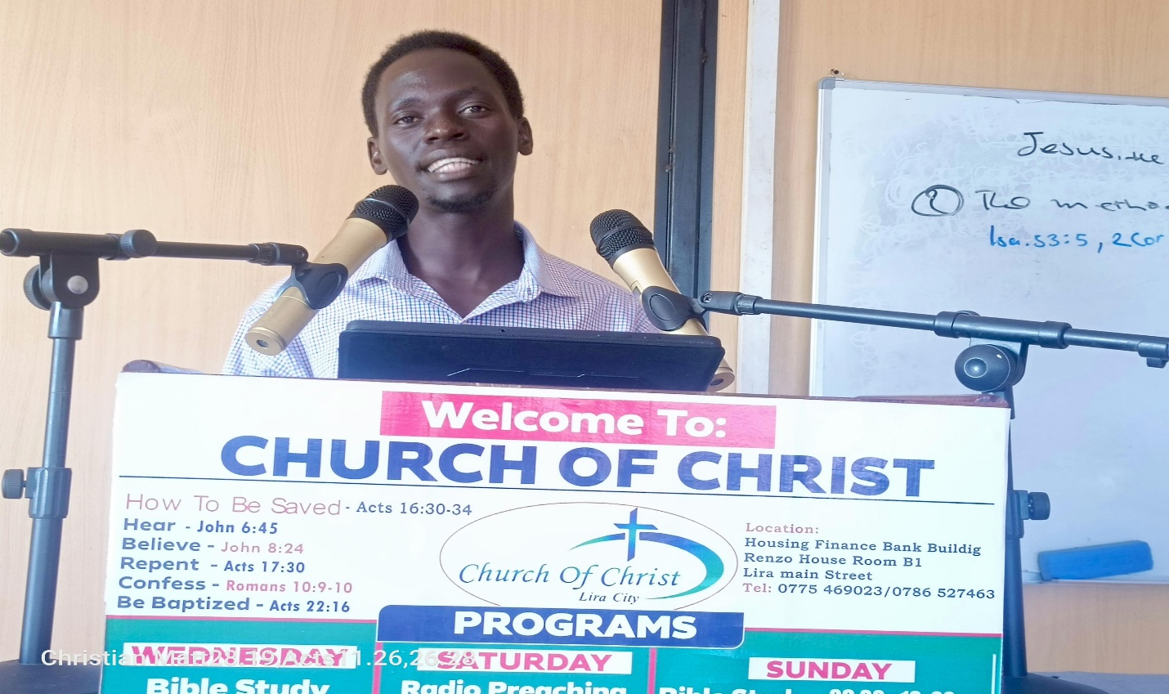
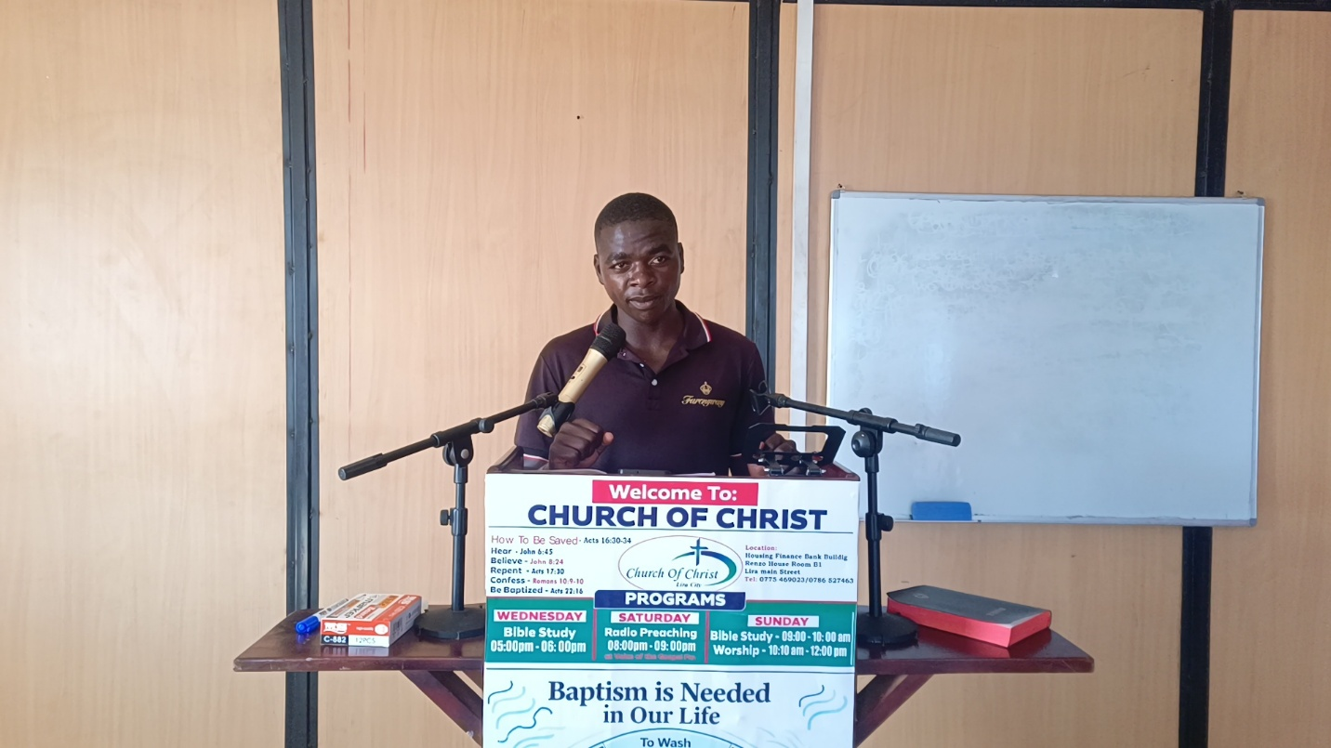

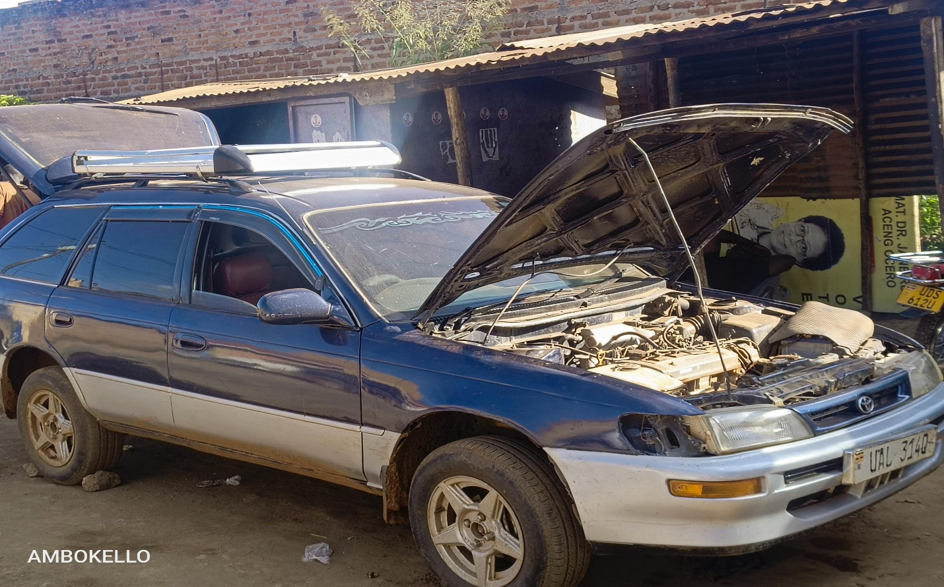
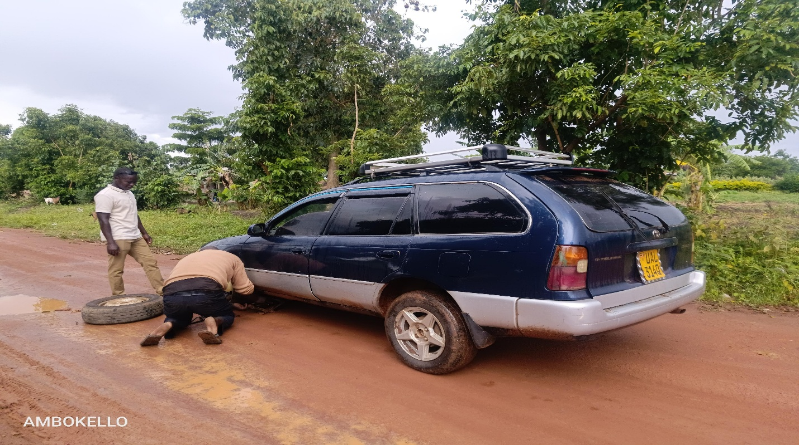

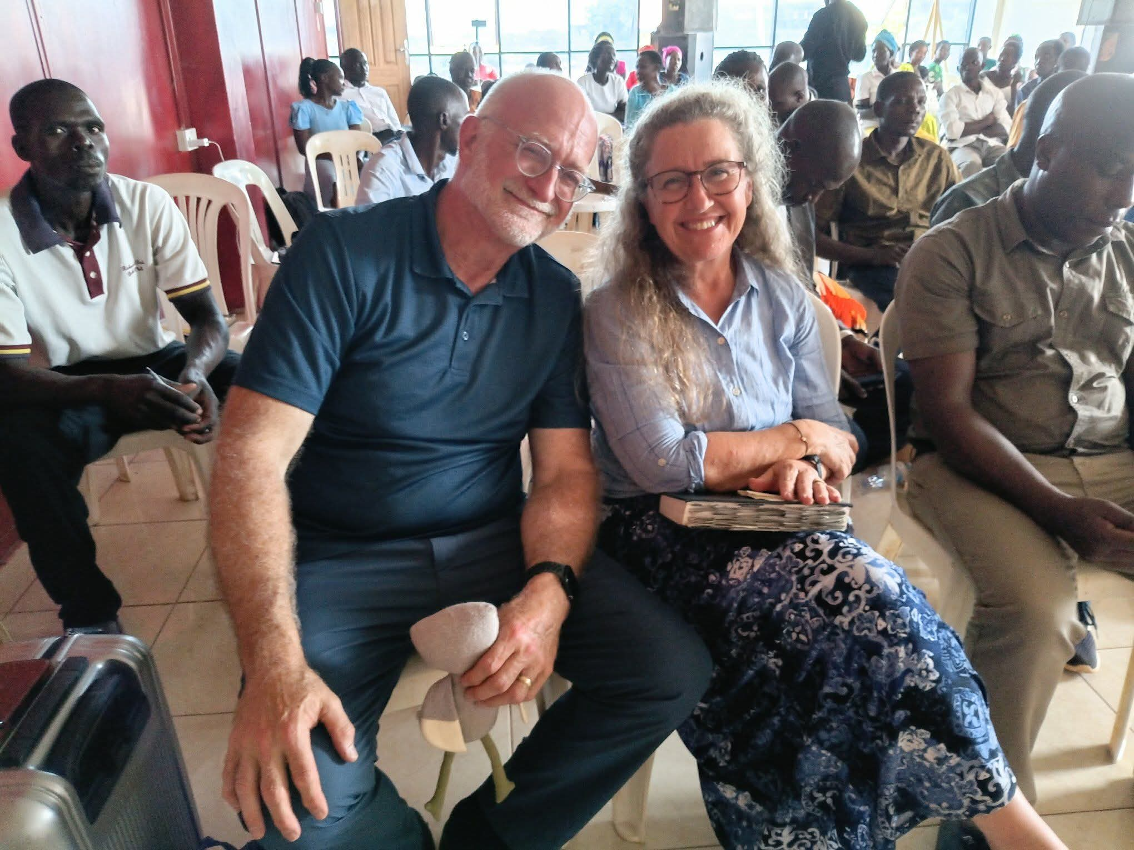
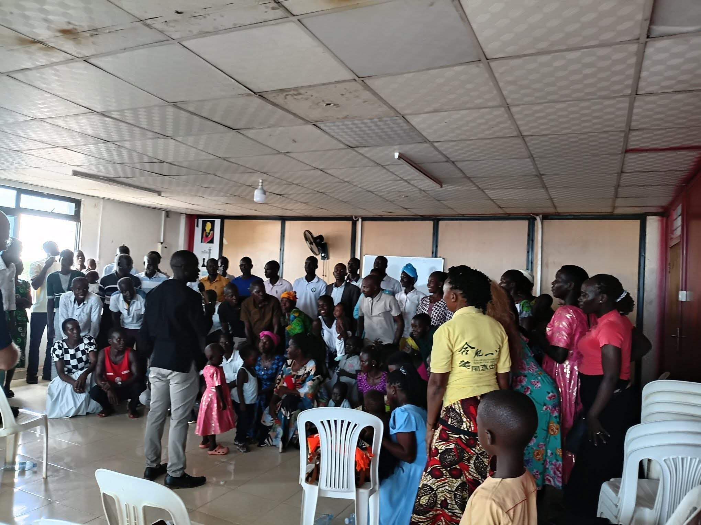
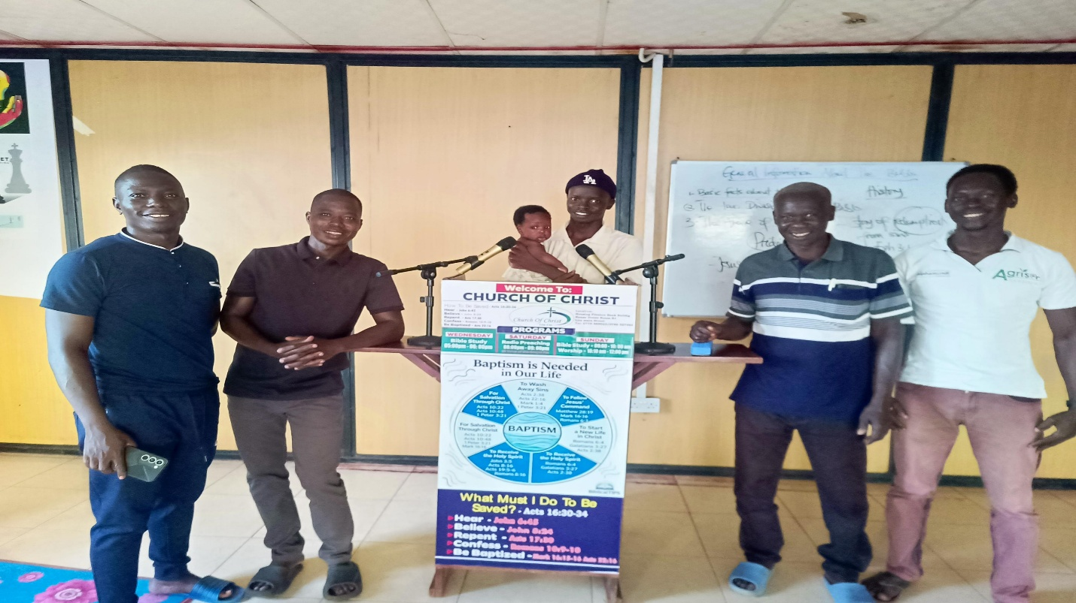

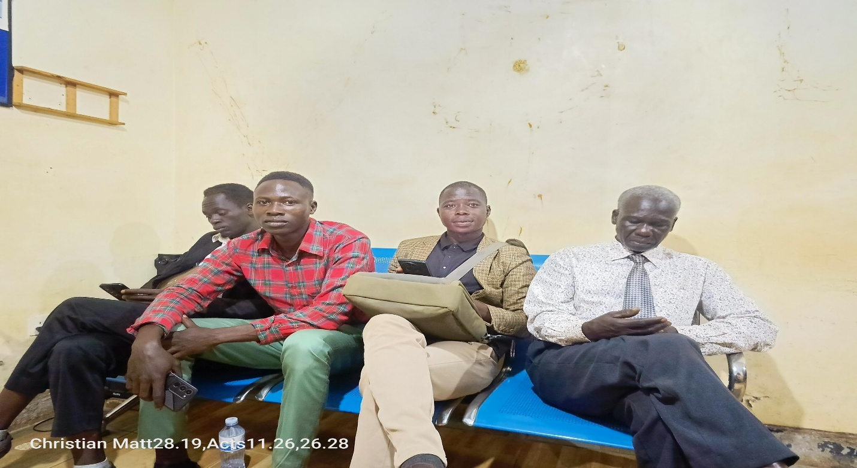
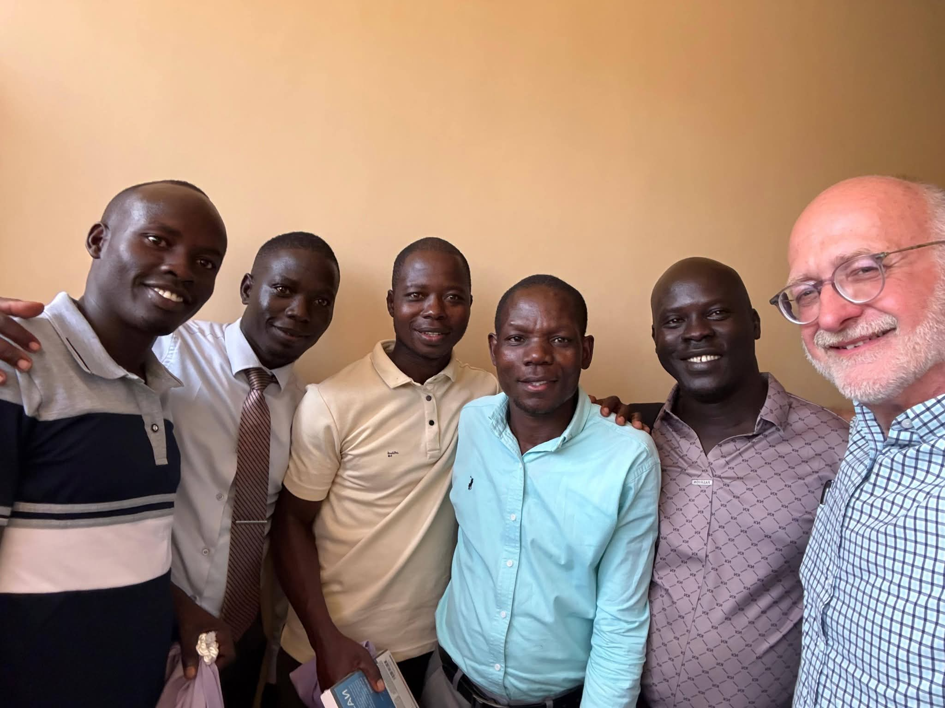

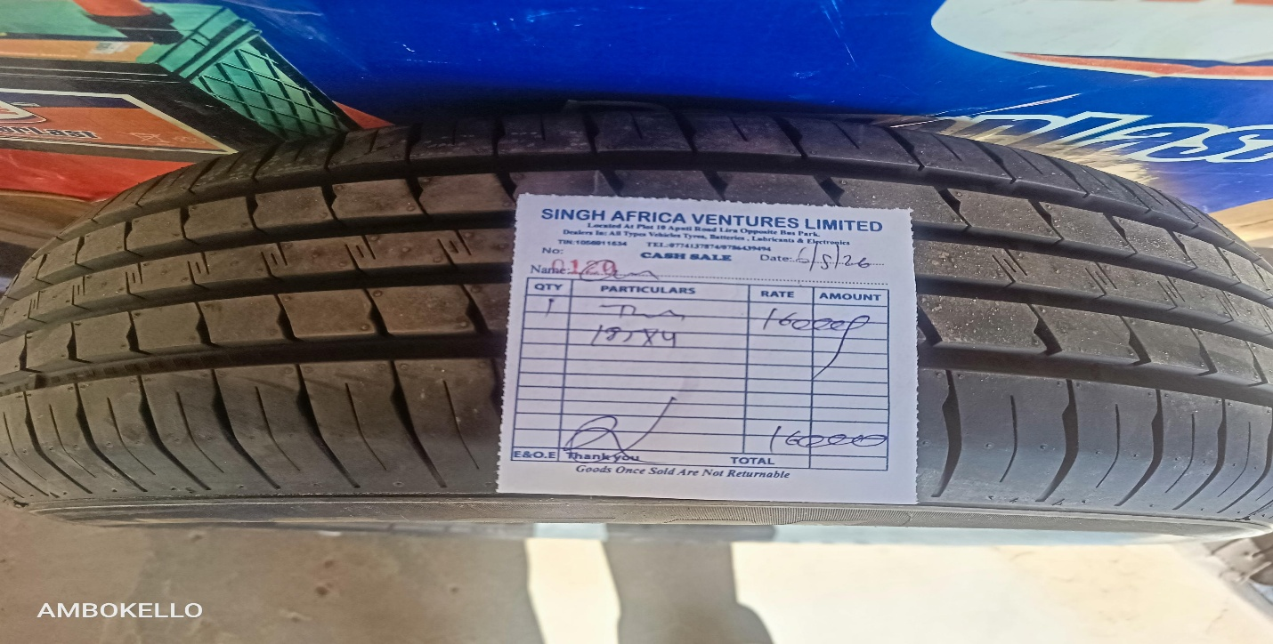
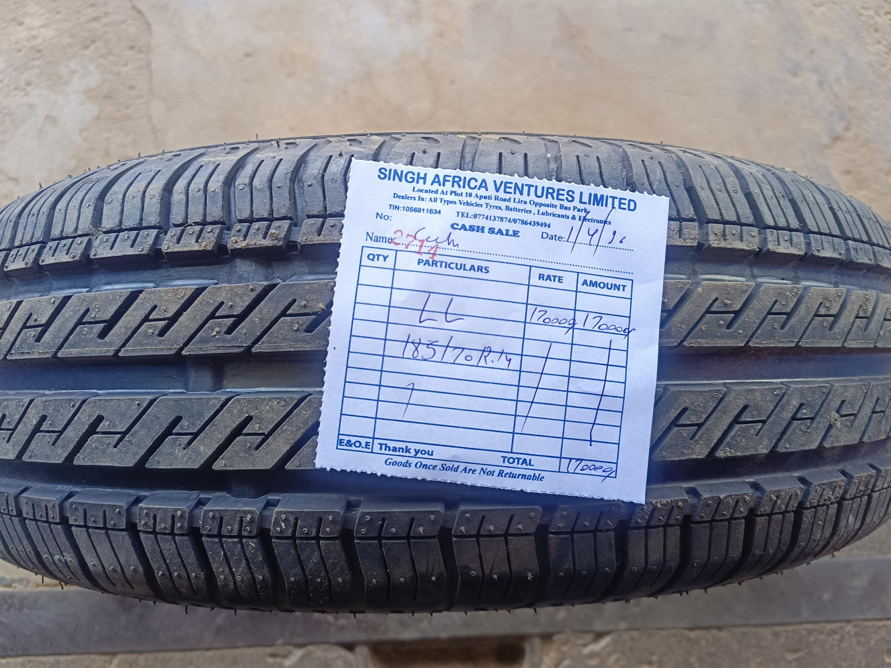
Again, wishing and praying for the very best for you from over Lord whom all blessings flow. Also that God is always glorified in the work we do together for Him.
Until Next Time – God Bless
In Christian Love and Fellowship - Bob.

